Partial / residual correlation: AUDUSD and USDCAD
Method 07 / daily log returns / leave-currency-out USD factor / Alpari D1 full available history

Study setup
Logical pair: AUDUSD , USDCAD
Broker symbols: AUDUSD_i , USDCAD_i
Snapshot: 2026-11-03_majors_alpari_D1
Timeframe: D1
Matched return window: 1999-01-05 to 2026-11-02 (UTC bar dates)
Matched return count n: 7148
Dropped unfinished last bar dated 2026-11-03 UTC after a tick-volume check against the prior complete day.
USD-strength sign rule: minus log return when USD is the quote (EURUSD, GBPUSD, AUDUSD, NZDUSD); plus log return when USD is the base (USDJPY, USDCHF, USDCAD). EURGBP is never a constituent.
Control z constituents (5): EURUSD, GBPUSD, NZDUSD, USDJPY, USDCHF
z_t = equal-weight mean of those USD-strength returns on the same day
Complete matched rows (Excel): AUDUSD-USDCAD_Partial_D1.xlsx
Complete matched rows (HTML table): AUDUSD-USDCAD_Partial_D1_data.html

Method carried forward
Partial / residual correlation regresses each matched daily log return of close, ln(close_t / close_t-1), on the same leave-currency-out USD strength factor z, then takes Pearson correlation of the two residual series. Quotes are not inverted. z is the equal-weight mean of USD-strength returns from other majors that do not share a non-USD currency with either leg; EURGBP is never a constituent. USD-strength is minus the log return when USD is the quote (EURUSD, GBPUSD, AUDUSD, NZDUSD) and plus the log return when USD is the base (USDJPY, USDCHF, USDCAD). OLS uses an intercept on each leg. rho_partial is symmetric under swap of the two symbols. It describes leftover linear co-movement after removing linear z; it is not a cause, not a lead, and not a trading signal. Daily rows are not independent and residuals are estimated, so the two-sided p-value and Fisher interval are secondary. Same-sample raw Pearson r is a side check only.

Regression on z
leg | intercept_a_or_c | slope_b_or_d | R2
AUDUSD | 2.863e-05 | -1.0624499 | 0.44093068
USDCAD | -1.074e-05 | 0.5498146 | 0.2542719

Results
rho_partial: -0.484843
Two-sided p-value: 0
Approximate 95% Fisher interval: [-0.502379, -0.466908]
Same-sample raw Pearson r: -0.647895
rho_partial minus r: 0.163052

Conclusion
Over 7148 matched daily rows for AUDUSD and USDCAD after removing a leave-currency-out USD factor built from 5 constituents, rho_partial is -0.4848 (negative, moderate residual linear link in this sample). Approximate 95% Fisher interval: [-0.5024, -0.4669]. Same-sample raw Pearson r is -0.6479 (partial minus r = 0.1631). Leg R-squared on z: AUDUSD=0.4409, USDCAD=0.2543. Two-sided p under the usual independent-pairs model is 0; residuals are estimated and daily FX rows are linked, so treat p as secondary. This does not establish cause, lead-lag, or a lasting trading rule.

Charts
Daily closes
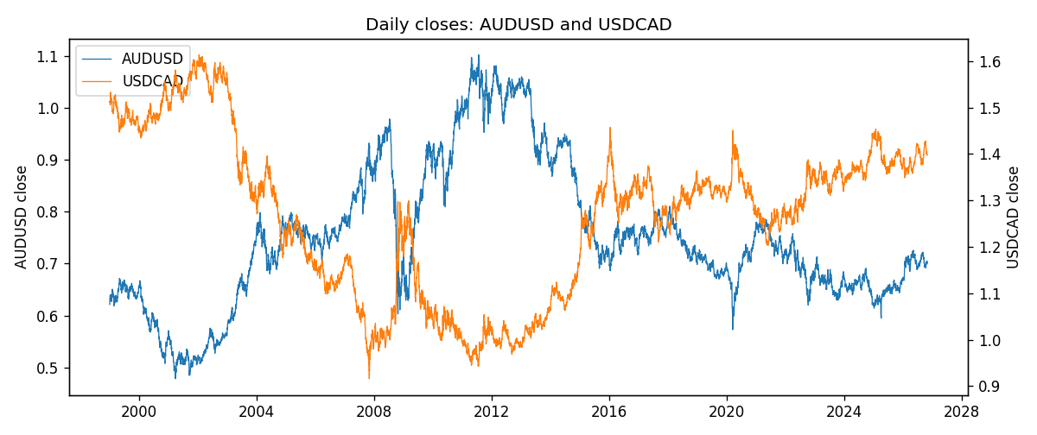
Log returns and control z
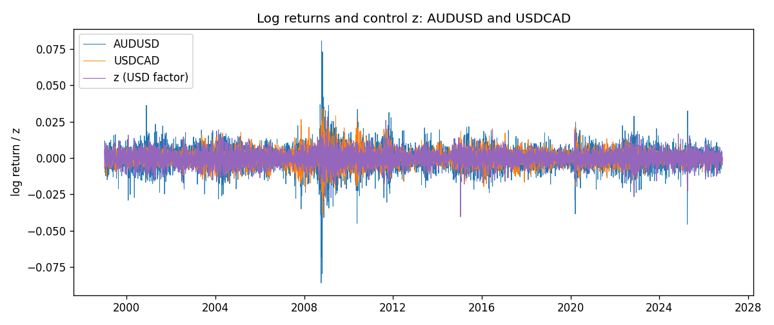
Residual scatter e_x vs e_y
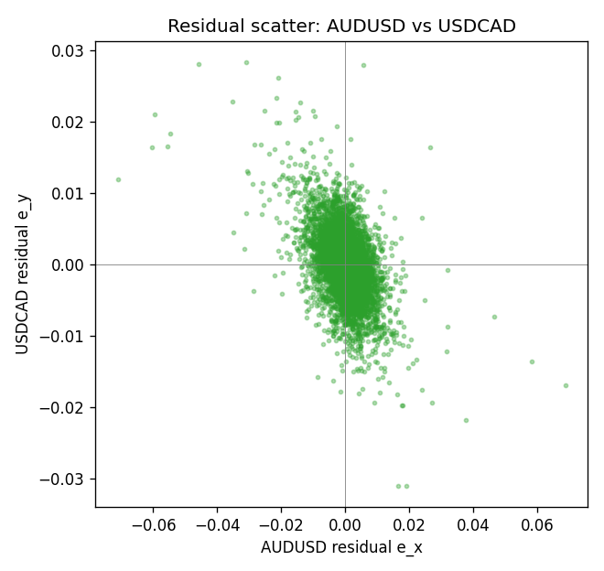

Data report
Every matched row that entered the partial correlation is stored in the sibling Excel workbook named AUDUSD-USDCAD_Partial_D1.xlsx. That file is the complete data archive for redrawing charts. Embedding all rows as a Word table is impractical at this length; the Word file holds the column list, column summaries, and the first and last 15 matched rows.
Columns: time, AUDUSD_open, USDCAD_open, AUDUSD_high, USDCAD_high, AUDUSD_low, USDCAD_low, AUDUSD_close, USDCAD_close, AUDUSD_tick_volume, USDCAD_tick_volume, AUDUSD_spread, USDCAD_spread, AUDUSD_real_volume, USDCAD_real_volume, AUDUSD_log_return, USDCAD_log_return, usd_strength_EURUSD, usd_strength_GBPUSD, usd_strength_NZDUSD, usd_strength_USDJPY, usd_strength_USDCHF, z, AUDUSD_fitted, USDCAD_fitted, AUDUSD_resid, USDCAD_resid
Column summaries (matched calculation rows)
column | count | mean | std | min | 25% | 50% | 75% | max
AUDUSD_open | 7148 | 0.75254463 | 0.13531821 | 0.4785 | 0.661255 | 0.7317 | 0.812135 | 1.10284
USDCAD_open | 7148 | 1.2664001 | 0.16881677 | 0.9168 | 1.1174225 | 1.29842 | 1.3719025 | 1.6183
AUDUSD_high | 7148 | 0.75660194 | 0.1358782 | 0.4878 | 0.6652025 | 0.7351 | 0.8182725 | 1.10795
USDCAD_high | 7148 | 1.2712993 | 0.16876756 | 0.9336 | 1.1224 | 1.30385 | 1.3760825 | 1.619
AUDUSD_low | 7148 | 0.74848743 | 0.13462984 | 0.4775 | 0.65803 | 0.727775 | 0.80652 | 1.0975
USDCAD_low | 7148 | 1.2618444 | 0.16884966 | 0.9056 | 1.1128375 | 1.29351 | 1.367575 | 1.6102
AUDUSD_close | 7148 | 0.75259994 | 0.13529833 | 0.4786 | 0.6614925 | 0.7318 | 0.81193 | 1.10169
USDCAD_close | 7148 | 1.2664179 | 0.16878481 | 0.916 | 1.117435 | 1.298405 | 1.3722025 | 1.6137
AUDUSD_tick_volume | 7148 | 77889.255 | 138502.92 | 109 | 5574 | 43696 | 71619 | 1234623
USDCAD_tick_volume | 7148 | 81445.79 | 147602.47 | 56 | 5642.25 | 41126 | 71764.5 | 1410818
AUDUSD_spread | 7148 | 30.707051 | 16.89031 | 0 | 13 | 30 | 50 | 50
USDCAD_spread | 7148 | 23.322888 | 18.222444 | 0 | 9 | 17 | 40 | 60
AUDUSD_real_volume | 7148 | 5.2809589e+09 | 1.2584371e+11 | 0 | 0 | 0 | 0 | 3.811512e+12
USDCAD_real_volume | 7148 | 1.8476363e+10 | 9.6948735e+10 | 0 | 0 | 0 | 0 | 2.5751613e+12
AUDUSD_log_return | 7148 | 3.157e-05 | 0.00755018 | -0.08602525 | -0.00385014 | 0.00029168 | 0.00415111 | 0.0806166
USDCAD_log_return | 7148 | -1.226e-05 | 0.00514518 | -0.03859748 | -0.00283513 | 4.873e-05 | 0.00272781 | 0.03436319
usd_strength_EURUSD | 7148 | 2.16e-06 | 0.0058013 | -0.03433183 | -0.00325609 | -0 | 0.00324218 | 0.03123819
usd_strength_GBPUSD | 7148 | 1.992e-05 | 0.00564699 | -0.03112653 | -0.00318167 | -3.426e-05 | 0.0031217 | 0.08388241
usd_strength_NZDUSD | 7148 | -1.914e-05 | 0.00764519 | -0.05966839 | -0.004586 | -0.00023666 | 0.00424201 | 0.07027433
usd_strength_USDJPY | 7148 | 5.267e-05 | 0.00620906 | -0.03908203 | -0.00319392 | 0.00012736 | 0.00340928 | 0.05184024
usd_strength_USDCHF | 7148 | -6.945e-05 | 0.0065937 | -0.19545699 | -0.00334697 | 8.15e-05 | 0.00331954 | 0.09051364
z | 7148 | -2.77e-06 | 0.00471883 | -0.04047177 | -0.00272051 | 7.481e-05 | 0.00273232 | 0.02831447
AUDUSD_fitted | 7148 | 3.157e-05 | 0.00501352 | -0.03005407 | -0.00287433 | -5.086e-05 | 0.00291904 | 0.04302786
USDCAD_fitted | 7148 | -1.226e-05 | 0.00259448 | -0.02226271 | -0.00150652 | 3.04e-05 | 0.00149153 | 0.01555697
AUDUSD_resid | 7148 | -0 | 0.00564534 | -0.07105063 | -0.00261001 | 0.00020368 | 0.00282098 | 0.06880218
USDCAD_resid | 7148 | 0 | 0.00444315 | -0.03105092 | -0.00245434 | -2.749e-05 | 0.00239619 | 0.02835261
First 15 matched rows (selected columns)
time | AUDUSD_close | USDCAD_close | AUDUSD_log_return | USDCAD_log_return | z | AUDUSD_fitted | USDCAD_fitted | AUDUSD_resid | USDCAD_resid
1999-01-05 | 0.6215 | 1.5123 | -0.00080418179 | -0.010131666 | 0.0026712488 | -0.0028094362 | 0.0014579528 | 0.0020052544 | -0.011589618
1999-01-06 | 0.6289 | 1.5118 | 0.011836351 | -0.0003306769 | 0.006255719 | -0.0066177562 | 0.0034287469 | 0.018454107 | -0.0037594238
1999-01-07 | 0.6345 | 1.5141 | 0.0088650256 | 0.0015202092 | -0.0068091277 | 0.0072629886 | -0.0037544965 | 0.001602037 | 0.0052747057
1999-01-08 | 0.6347 | 1.511 | 0.00031515916 | -0.0020495197 | 0.0047240925 | -0.0049904798 | 0.0025866363 | 0.0053056389 | -0.004636156
1999-01-11 | 0.6393 | 1.5057 | 0.0072213815 | -0.0035137769 | -0.0016802217 | 0.0018137831 | -0.00093454918 | 0.0054075984 | -0.0025792278
1999-01-12 | 0.6362 | 1.5157 | -0.0048608485 | 0.0066194721 | 0.004204496 | -0.0044384345 | 0.0023009545 | -0.00042241398 | 0.0043185176
1999-01-13 | 0.6312 | 1.5226 | -0.0078902098 | 0.0045420214 | -0.0040253091 | 0.004305321 | -0.0022239125 | -0.012195531 | 0.0067659339
1999-01-14 | 0.6295 | 1.5332 | -0.002696916 | 0.0069376546 | -0.00083553058 | 0.00091634113 | -0.00047012567 | -0.0036132572 | 0.0074077803
1999-01-15 | 0.634 | 1.5245 | 0.007123101 | -0.0056905671 | 0.0072257255 | -0.0076483394 | 0.0039620706 | 0.01477144 | -0.0096526377
1999-01-18 | 0.6346 | 1.526 | 0.00094592471 | 0.00098344542 | -0.0012150399 | 0.0013195508 | -0.00067878544 | -0.00037362606 | 0.0016622309
1999-01-19 | 0.6392 | 1.5302 | 0.0072225153 | 0.002748513 | -0.0018512813 | 0.0019955254 | -0.0010286003 | 0.0052269899 | 0.0037771132
1999-01-20 | 0.64 | 1.5211 | 0.0012507819 | -0.0059646885 | 0.0011715876 | -0.0012161213 | 0.00063341718 | 0.0024669032 | -0.0065981057
1999-01-21 | 0.6405 | 1.5146 | 0.00078094498 | -0.0042823796 | -0.0011186197 | 0.0012171092 | -0.00062577222 | -0.00043616419 | -0.0036566074
1999-01-22 | 0.6327 | 1.5184 | -0.012252745 | 0.0025057712 | 0.003335548 | -0.0035152208 | 0.0018231942 | -0.0087375244 | 0.00068257696
1999-01-25 | 0.6302 | 1.5197 | -0.0039591468 | 0.00085579808 | 9.2850518e-05 | -7.0017259e-05 | 4.0311811e-05 | -0.0038891296 | 0.00081548627
Last 15 matched rows (selected columns)
time | AUDUSD_close | USDCAD_close | AUDUSD_log_return | USDCAD_log_return | z | AUDUSD_fitted | USDCAD_fitted | AUDUSD_resid | USDCAD_resid
2026-10-13 | 0.69821 | 1.4214 | 0.0035007712 | -0.0046395653 | -0.0033010377 | 0.0035358189 | -0.0018256975 | -3.504775e-05 | -0.0028138678
2026-10-14 | 0.69715 | 1.42356 | -0.0015193215 | 0.0015184751 | 0.0030839949 | -0.0032479582 | 0.0016848866 | 0.0017286367 | -0.00016641157
2026-10-15 | 0.69191 | 1.41843 | -0.0075447063 | -0.0036101503 | -0.0057208803 | 0.0061067803 | -0.0031561622 | -0.013651487 | -0.00045398809
2026-10-16 | 0.69426 | 1.41357 | 0.0033906408 | -0.0034322068 | -0.0030569277 | 0.0032764642 | -0.0016914822 | 0.00011417653 | -0.0017407245
2026-10-19 | 0.6978 | 1.41091 | 0.0050859986 | -0.0018835331 | 0.0019055287 | -0.001995897 | 0.0010369487 | 0.0070818956 | -0.0029204818
2026-10-20 | 0.70022 | 1.40569 | 0.0034620426 | -0.0037066008 | -0.0033166464 | 0.0035524024 | -0.0018342794 | -9.0359744e-05 | -0.0018723215
2026-10-21 | 0.70275 | 1.4045 | 0.0036066384 | -0.00084691787 | -0.00094972159 | 0.0010376634 | -0.00053290955 | 0.0025689751 | -0.00031400832
2026-10-22 | 0.70186 | 1.40081 | -0.0012672558 | -0.0026307268 | -0.0017446765 | 0.0018822631 | -0.00096998737 | -0.003149519 | -0.0016607395
2026-10-23 | 0.70353 | 1.40085 | 0.0023765656 | 2.85545e-05 | 0.0012727098 | -0.0013235586 | 0.00068901568 | 0.0037001243 | -0.00066046118
2026-10-26 | 0.70128 | 1.40093 | -0.0032032829 | 5.7106554e-05 | 0.0027137572 | -0.0028545992 | 0.0014813245 | -0.00034868371 | -0.001424218
2026-10-27 | 0.70245 | 1.40449 | 0.0016669876 | 0.0025379458 | 0.0024312796 | -0.002554481 | 0.0013260143 | 0.0042214686 | 0.0012119315
2026-10-28 | 0.70533 | 1.39911 | 0.0040915541 | -0.0038379274 | 0.00079078229 | -0.00081153478 | 0.00042404489 | 0.0049030889 | -0.0042619723
2026-10-29 | 0.70245 | 1.39895 | -0.0040915541 | -0.00011436495 | -0.002343138 | 0.0025180985 | -0.0012990302 | -0.0066096526 | 0.0011846653
2026-10-30 | 0.70316 | 1.39751 | 0.0010102376 | -0.0010298736 | -0.00014765901 | 0.00018551206 | -9.1923836e-05 | 0.00082472558 | -0.00093794974
2026-11-02 | 0.69971 | 1.39837 | -0.0049184984 | 0.00061519094 | -0.0010247043 | 0.0011173287 | -0.00057413613 | -0.0060358271 | 0.0011893271

